Written by Sara Kwon and Jamie Ladipo
BECOMING A HOST

Communal Evangelism Toolkit

COMMUNAL EVANGELISM | BECOMING A HOST

Becoming a Host: Learning to See
In John 4, in the heat of the day, Jesus meets a woman beside a well. While there are many things to draw out of her story, simply put, Jesus sees this woman and makes space for her. And in so doing he engages her spiritual questions and she meets the Messiah who knows her and cares for her. Moments later, Jesus engages his disciples. Jesus invites his disciples to share in his ministry of seeing and creating space for others. “Look, the fields are ripe with harvest!” ​
Just like Jesus told the disciples to see the fields, Jesus calls your chapter to do the same. Together as a community, you are called to see not just those already involved in your chapter, but every Asian/Asian American on your campus. Jesus sees every person and their story, and he calls all of us, his disciples, to see and honor them as well, just as he sees and honors each of our stories as Asian Americans.

As your chapter learns to see and create a space for those who aren’t yet Christian:​
- you will grow as disciples​
- your non-Christian friends will be seen and can engage their questions, and ​
- your chapter will be transformed​

There is a misconception that the best relationships unfold naturally, without intentionality. But, in fact, the relationships we care the most about are loaded with intentionality. When you think about what would make a birthday special, or who you want to join you on the opening day of a favorite movie, you are intentionally building that relationship. As Christians, we may feel like being intentional with our non-Christian friends would be inorganic, but in fact, as we deepen our relationships with our friends, we should naturally become more intentional. And that intentionality communicates to our friends our care and concern. ​

Your Role as a Host
In the coming weeks you will learn skills and be given strategies to help your chapter grow to see those outside your chapter and create spaces for non-Christians along the BEC ramp. You have an important role in your witness and the witness of your chapter. You are a host. The Lord has sent you and your chapter to be a host to his work on your campus. ​
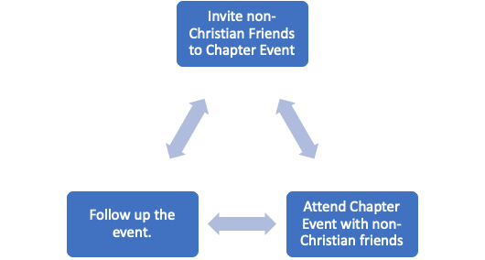
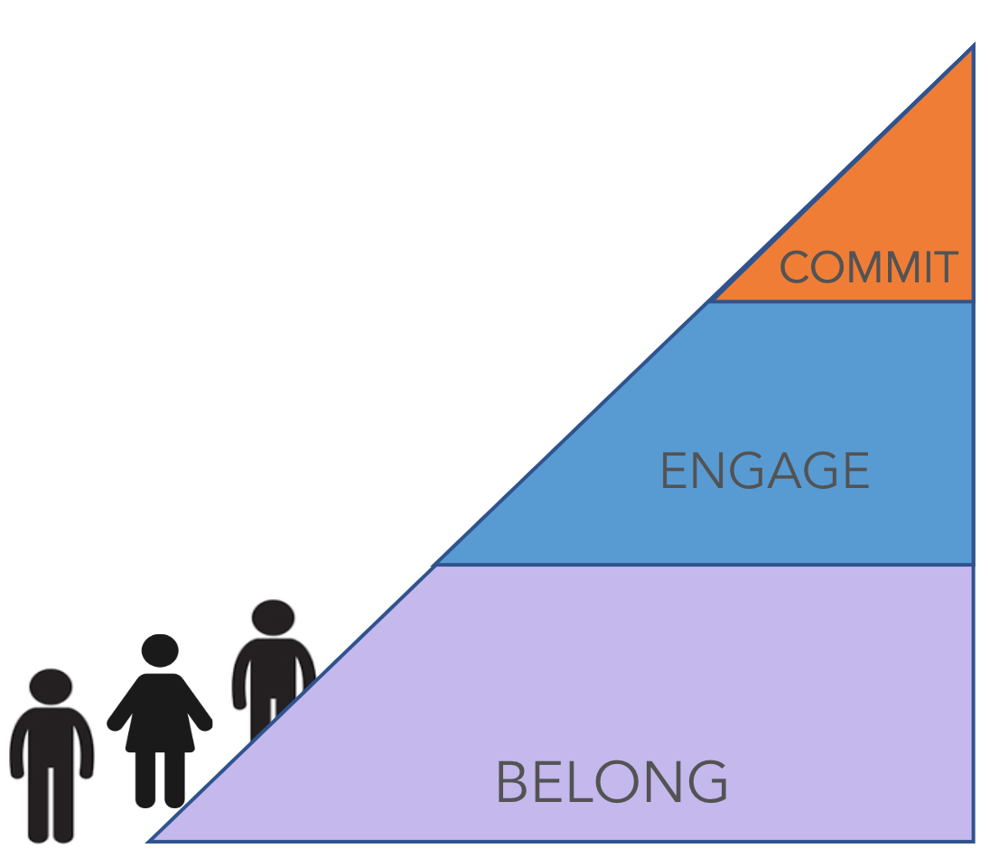
Invitations to hear the Gospel.
Follow-up conversations about what their decision meant.

Invitations to spiritual engagement.
Follow-up conversations about their journey.

Invitations to fun.
Follow-up conversations
to deepen your friendship.
As a host, you will be equipped with 3 skills:
- Invite friends and strangers as they journey along the ramp.
- Attend events with them.
- Follow up after each event.

​
At each part of the ramp, our role is to invite, journey with people, and follow up. As your community practices invitation, journeying with people, and follow up, you will grow in your hospitality and witness and get to see God move in people’s lives.

Discuss
- How do you feel about becoming a host, and specifically about making invitations, journeying with people, and following up? Which comes easiest for you? Which is hardest?
- As a community, how have you already been good hosts to non-Christians and new students? How would you like to grow this year?

Next Steps
Individually: This week, pray for God to equip you to be a host. Look for God’s hospitality to you as you extend hospitality to others.
Communally: At the next meetings, go through the Invitations into Community and Follow Up trainings in the Communal Evangelism toolkit.

