**Small group example #1 (2-20ish participants):**

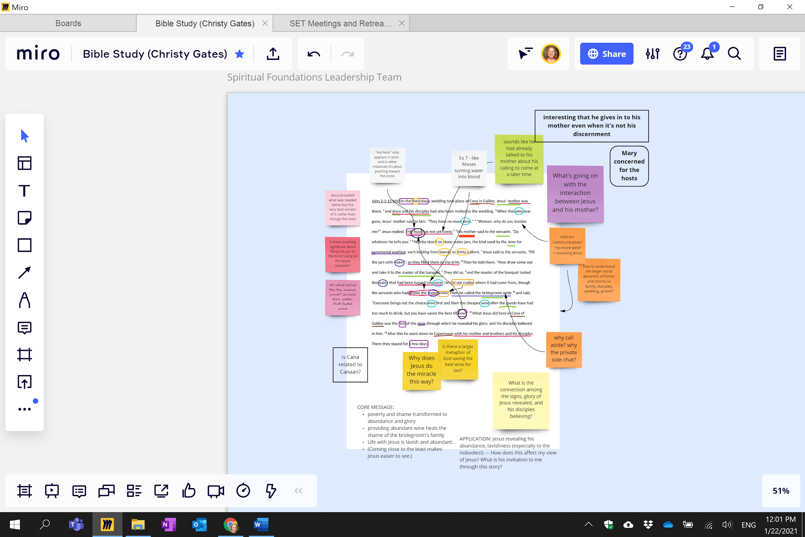

**Small group example #2 (2-20ish participants):**

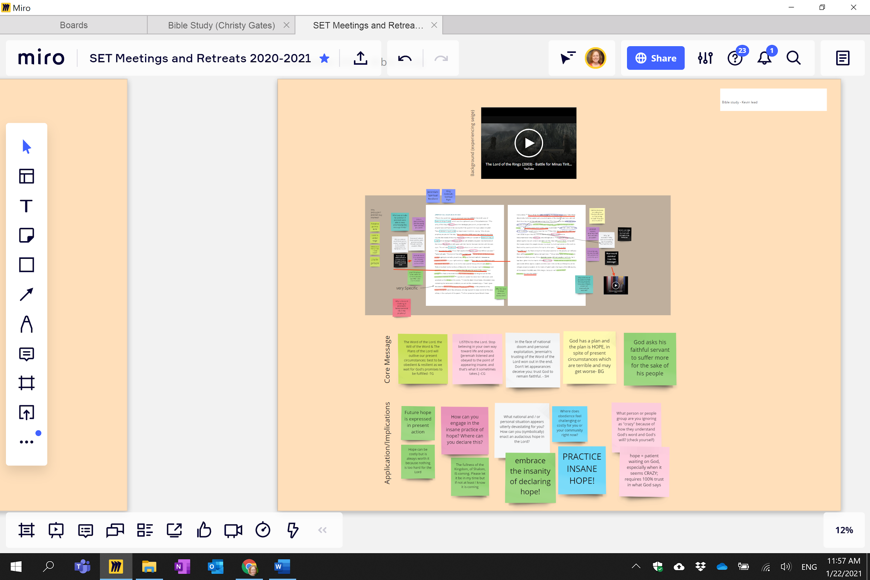

**Large group example (15-100+ participants):**

***Please feel free to email*** [***christy.gates@intervarsity.org***](mailto:christy.gates@intervarsity.org) ***with any questions about leading this large group style.***

