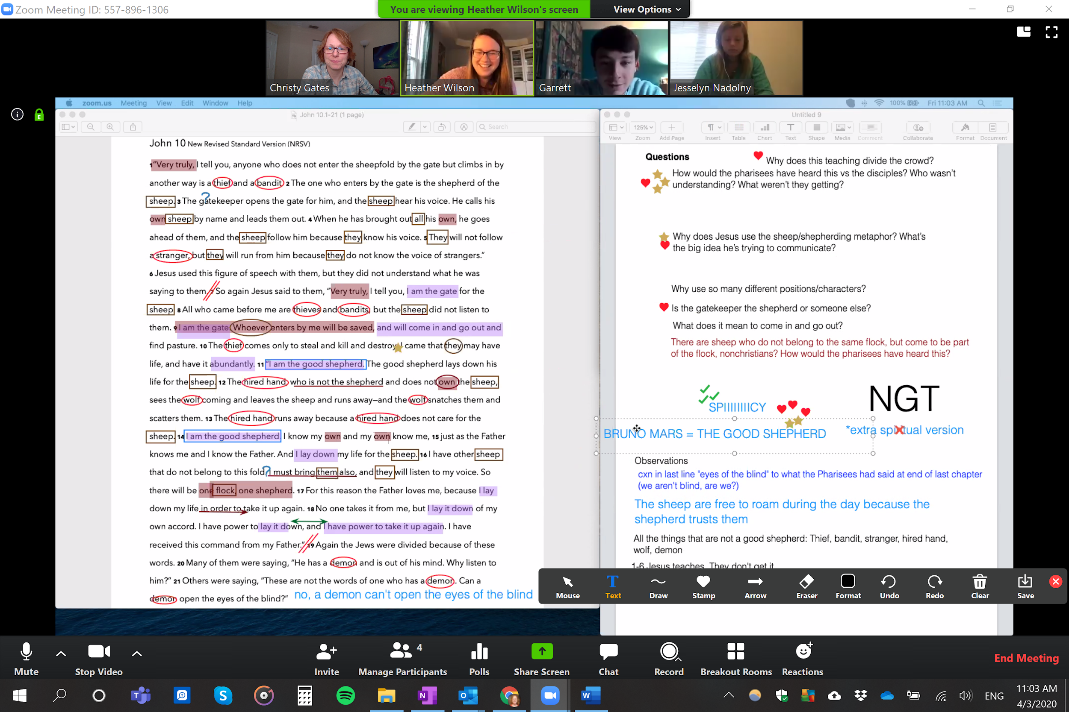

Screenshot example of online MBS using Zoom annotate