Where is Your Treasure?
Quarterly Retreat June 2025
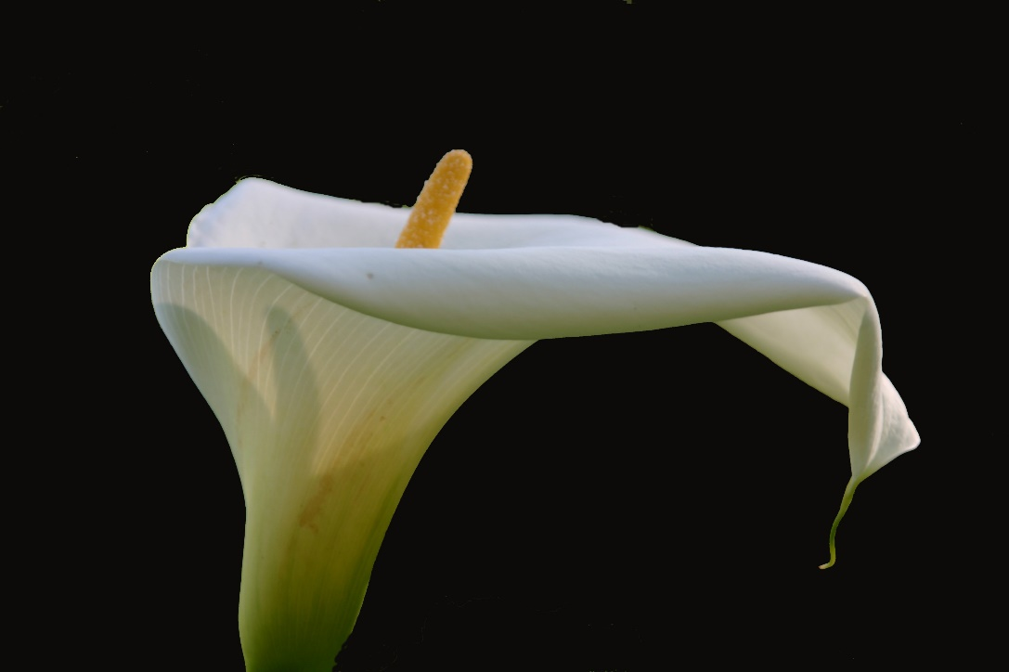
Read the passage below a couple of times.
Pay attention to the words or phrases that seem to grab you.
Linger awhile with them.

Luke 12:21-34
“So it is with those who store up treasures for themselves but are not rich toward God.
Jesus said to his disciples, “Therefore I tell you, do not worry about your life, what you will eat, or about your body, what you will wear. For life is more than food, and the body more than clothing. Consider the ravens: they neither sow nor reap, they have neither storehouse nor barn, and yet God feeds them. Of how much more value are you than the birds! And can any of you by worrying add a single hour to your span of life? If then you are not able to do so small a thing as that, why do you worry about the rest? Consider the lilies, how they grow: they neither toil nor spin; yet I tell you, even Solomon in all his glory was not clothed like one of these. But if God so clothes the grass of the field, which is alive today and tomorrow is thrown into the oven, how much more will he clothe you—you of little faith! And do not keep striving for what you are to eat and what you are to drink, and do not keep worrying. For it is the nations of the world that strive after all these things, and your Father knows that you need them. Instead, strive for his kingdom and these things will be given to you as well.

Do not be afraid little flock, for it is your Father’s good pleasure to give you the kingdom. Sell your possessions, and give alms. Make purses for yourselves that do not wear out, an unfailing treasure in heaven, where no thief comes near and no moth destroys. For where your treasure is, there your heart will be also.”

Allow yourself to rest in Jesus’ words to you.
- What are the things, situations, or people you are worried or concerned about? What seems to be weighing heavily on you? Are you carrying something that maybe you are not supposed to be carrying?

- Name each of those things that are concerns. Call a truce of worries and one by one, cast each to Jesus, for he cares for you. Let him, at least for the time you are here, manage those things for you. You may want to picture him receiving those situations or people or decisions from you. And you may want to consider how you will want to carry those things once you leave.

- Consider the relationship of working….striving….worrying…and God feeding and clothing us and knowing our needs. What is the work God has given you to do? What is God’s work? What does it mean for you to be a person of faith as it pertains to your work and ministry?

Now, go outside, if you are able, and find some flowers or grass or do some bird watching. We rarely take time to consider these things, as Jesus instructed us. But here you are on retreat, so take the time. If you are unable to go outside, at least consider the photo of the calla lily at the top of the other page. Here is a way to consider a flower, or grass or a bird:

- OBSERVE: What is this object? How does it feel? Smell? Look? What words can I use to describe it to someone else?

- INTERPRET: What is the function or purpose of this object? How did it get here? What can I learn about the Creator from this object, the creation? How does it fit in with its surroundings? What impact does it make? What is it’s affect on me?

- APPLY: What can I learn about God through this object? How might this lesson relate to my life TODAY? What might God want to teach me?

Think about this: “it is your Father’s good pleasure to give you the kingdom.”
- What have you known of God’s good pleasure lately?

- Where do you want to see more of God’s kingdom? What might that look like? Spend some time praying to that end.

- How do you want to be “rich toward God”? What does and will that look like in your life?

Reading for Reflection

Norman Harrison, in His in a Life of Prayer tells how Charles Inglis, while making the voyage to America a number of years ago, learned from the devout and godly captain of an experience which he had had with George Mueller of Bristol. It seems that they had encountered a very dense fog. Because of it the captain had remained on the bridge continuously for 24-hours, when Mr. Mueller came to him and said, “Captain, I have come to tell you that I must be in Quebec on Saturday afternoon.” When informed that it was impossible, Mueller replied, “Very well. If the ship cannot take me, God will find some other way. I have never broken an engagement for 57 years. Let us go down into the chartroom and pray.”

The captain continues the story thus: “I looked at that man of God and thought to myself, What lunatic asylum could that man have come from. I never heard such a thing as this. ‘Mr. Mueller,’ I said, ‘do you know how dense this fog is?’ ‘No,’ he replied, ‘my eye is not on the density of the fog, but on the living God, who controls every circumstance of my life.’ He knelt down and prayed one of those simple prayers, and when he had finished I was going to pray; but he put his hand on my shoulder and told me not to pray, ‘Firstly,’ he said, ‘because you do not believe God will, and secondly, I believe God has, and there is no need whatever for you to pray about it.’ I looked at him, and George Mueller said, ‘Captain, I have known my Lord for 57 years, and there has never been a single day that I have failed to get an audience with the King. Get up and open the door and you will find that the fog has gone.’ I got up and the fog was indeed gone. George Mueller was in Quebec Saturday afternoon for his engagement.
--From I Will Lift Up My Eyes by Glenn Clark

Talk to Jesus about what strikes you from this story. As you approach the end of this academic year, where in your life do you need/want this kind of faith?

Closing Prayer

God before me, God behind me,
God above me, God beneath me.
I on your path, O God.
You, O God, on my way.
In the twisting of the road
In the currents of the river
Be with me by day
Be with me by night
Be with me by day and by night.

--J. Philiip Newell, Celtic Prayers from Iona

